The Tableau HR Scorecard: Measuring Success in Talent Management.

Team Members

by:

* Thiyagesa jeya harini B

*Jaya karthika G

* Petchimmal M

* Ramalakshmi V

**CATEGORY:** Data Analytics with Tableau

**PROJECT TITLE:** THE TABLEAU HR SCORECARED:MEASURING SUCCESS IN TALENT MANAGMENT

**INTRODUCTION:**

1.Overview: A brief description about your project

2.Purpose: The use of this project. What can be achieved using this.

**Problem Definition & Design Thinking**

**The Tableau HR Scorecard: Measuring Success in Talent Management**

The Tableau HR Scorecard is a framework designed to measure and evaluate the success of talent management strategies within an organization. It provides a way for HR professionals and business leaders to track and analyze key performance indicators (KPIs) related to workforce planning, recruitment, retention, and development.

**The HR Scorecard consists of four main perspectives:**

1.Perspective:

This perspective focuses on the financial impact of HR initiatives, such as the cost of recruitment, training and Financial development, compensation and benefits, and turnover.

2. Customer Perspective:

This perspective measures the satisfaction of internal and external customers of HR services, including employees, managers, and job candidates. It includes KPIs such as employee engagement, manager satisfaction with HR support, and candidate experience.

3. Internal Process Perspective

This perspective assesses the effectiveness and efficiency of HR processes, such as recruiting, onboarding, performance management, and employee development. It includes KPIs such as time to fill vacancies, time to productivity for new hires, and training hours per employee.

4. Learning and Growth Perspective:

This perspective evaluates the organization's investment in employee development and its ability to innovate and adapt to changing business needs. It includes KPIs such as employee skills and competencies, employee retention, and the percentage of employees who receive regular training and development.

**To accomplish this, we have to complete all the activities listed below:**

Define Problem / Problem Understanding

● Specify the business problem

● Business requirements

● Literature Survey

● Social or Business Impact.

**EMPATHY MAP:**

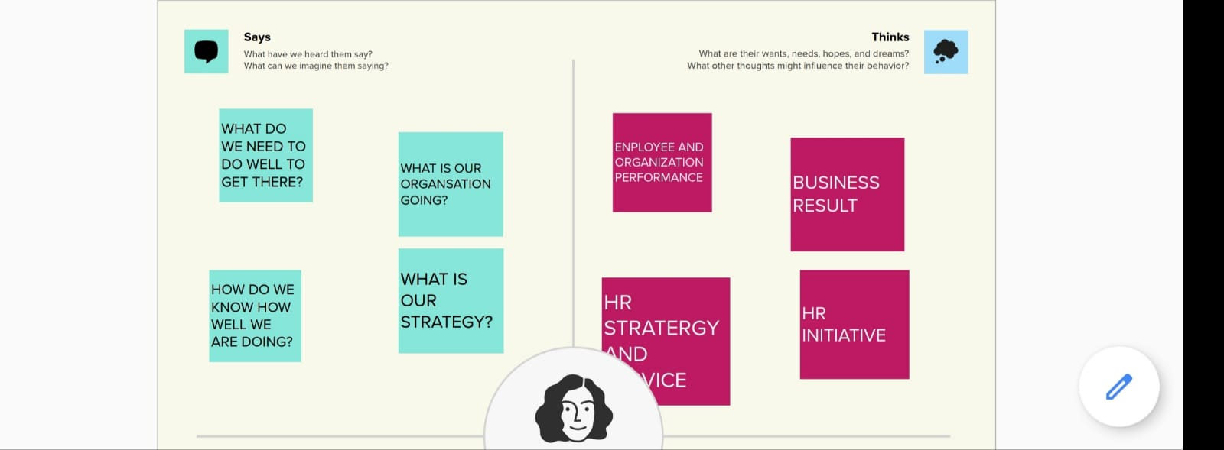

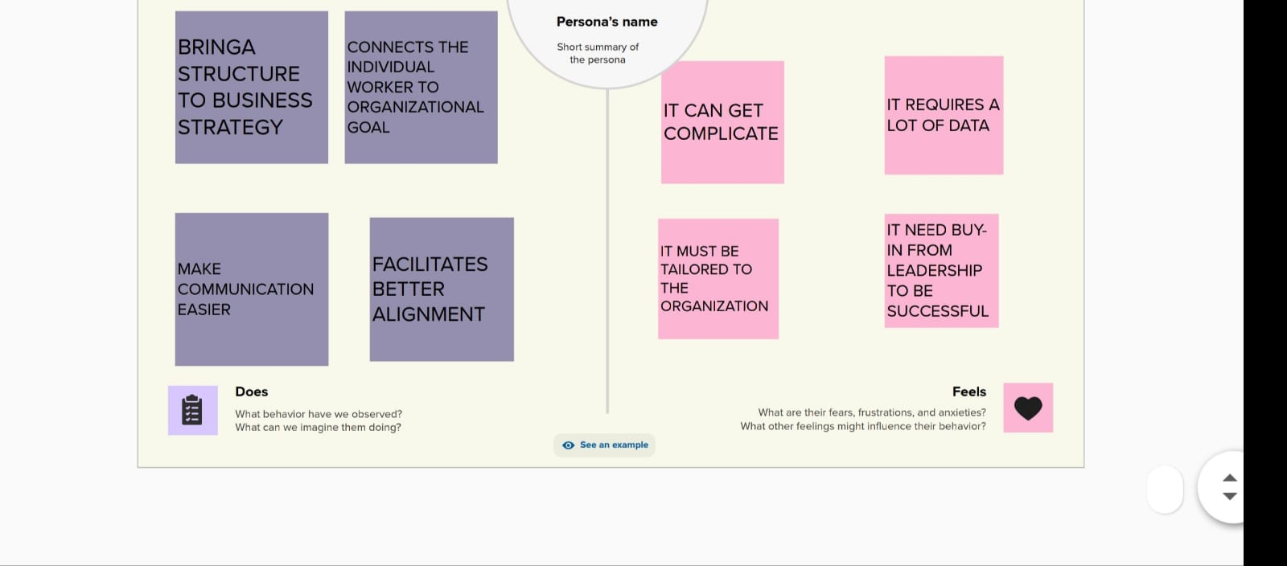

**BRAINSTROM:** 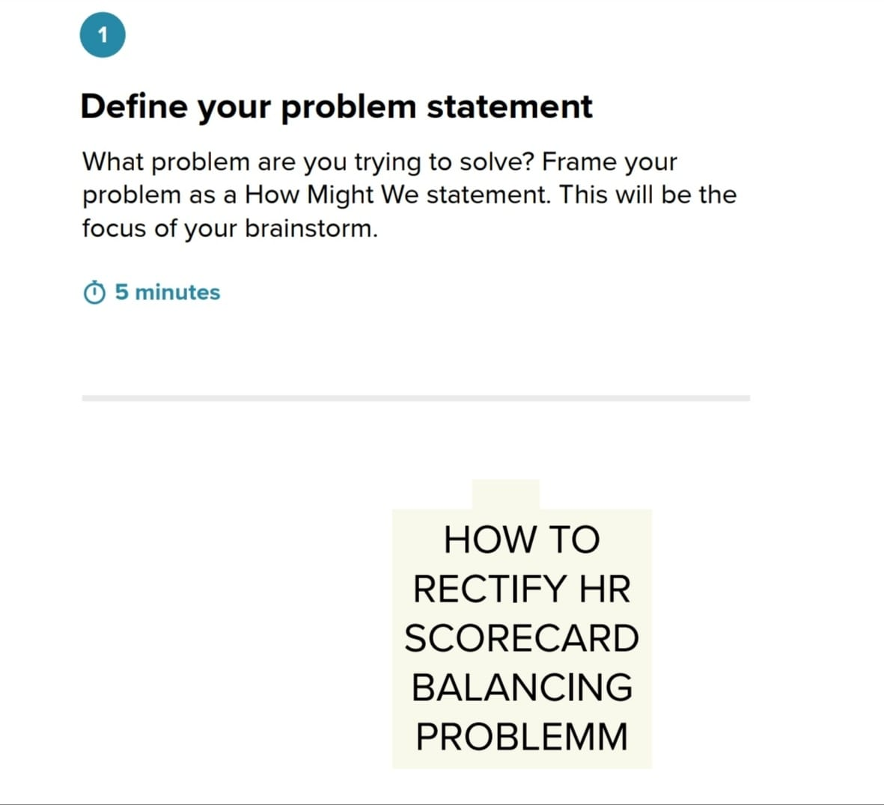

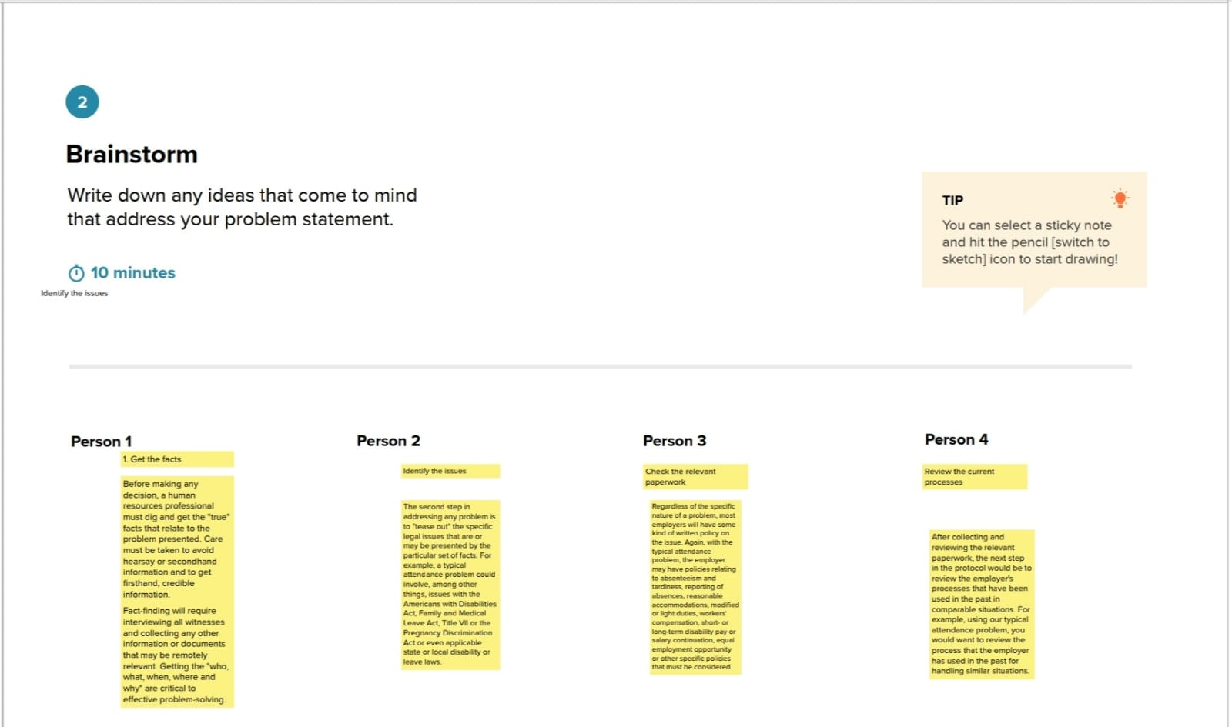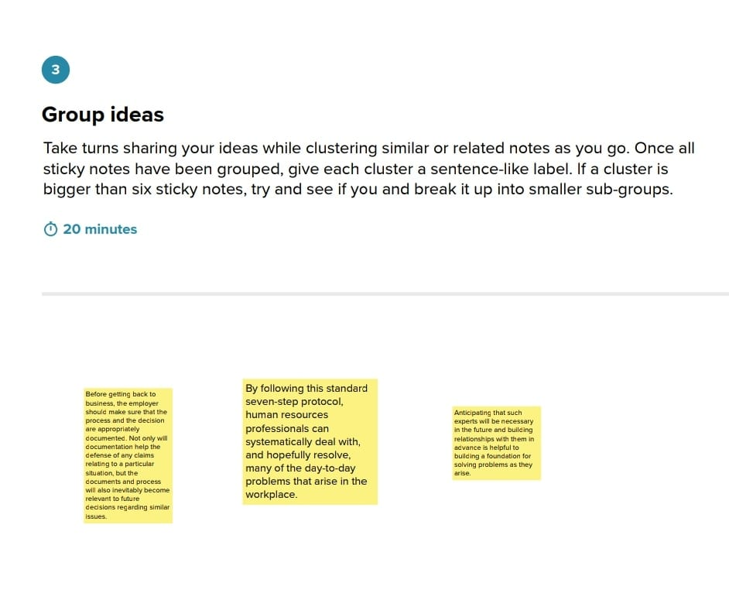

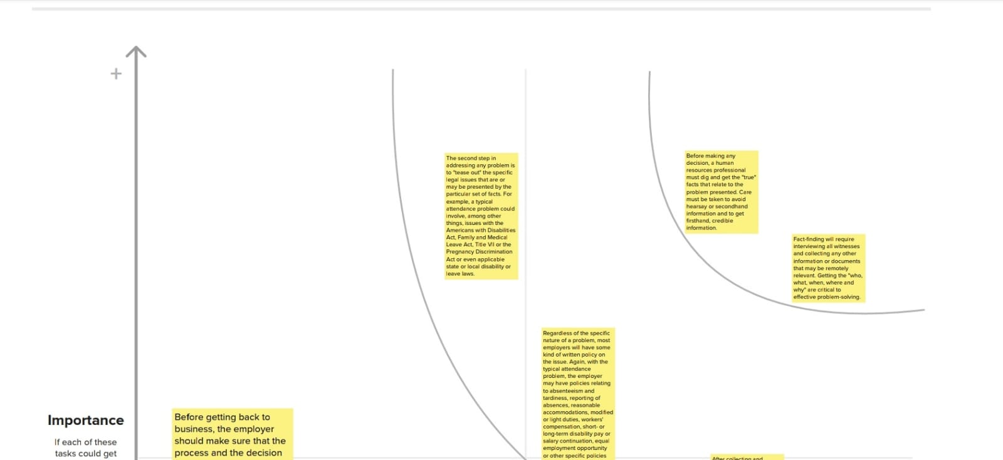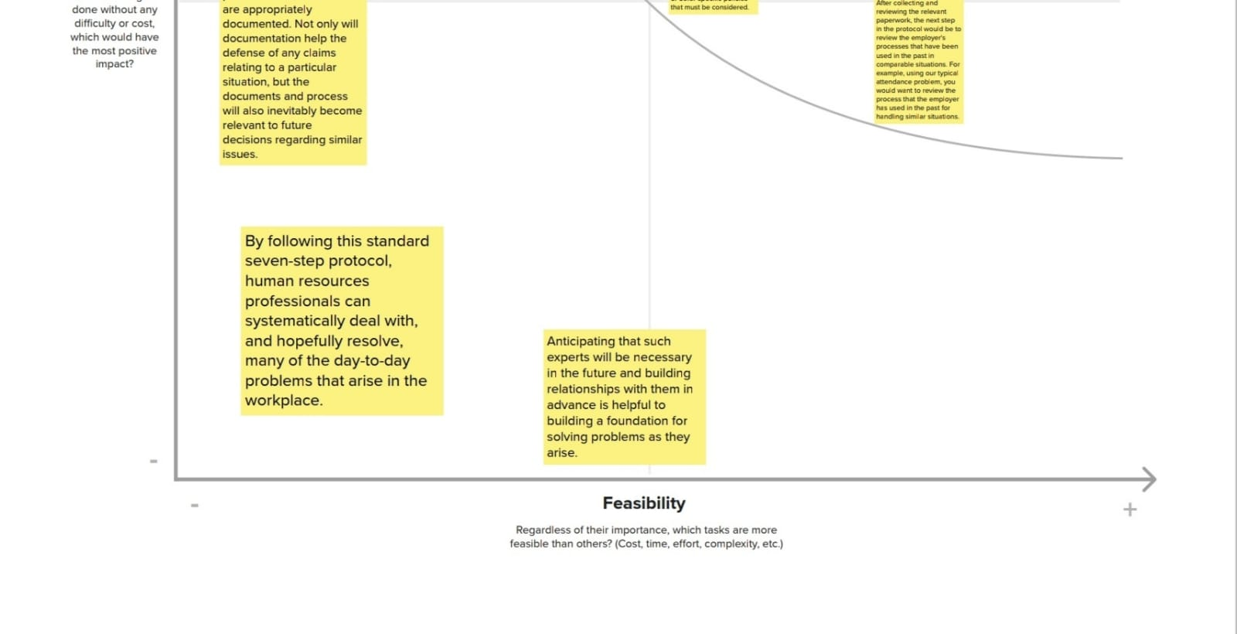 **Specify the business problem The Tableau HR Scorecard: Measuring Success in Talent Management**

**Business requirements**

The business requirement of The Tableau HR Scorecard: Measuring Success in Talent Management is to provide a comprehensive and effective framework for measuring and evaluating the success of talent management strategies within an organization. The primary goal is to enable HR professionals and business leaders to track and analyze key performance indicators (KPIs) related to workforce planning, recruitment, retention, and development. We can do so by creating interactive dashboards and reports, making data-driven decisions and creating forecasting models for future performance. The ultimate goal is to gain insights and improve performance through data visualization techniques.

**Literature Survey**

A literature survey is a method of researching existing literature and studies related to a specific topic. In the context of Measuring Success in Talent Management, a literature survey would involve reviewing studies and articles that have been published on the topic of vehicle collisions. The literature survey would include sources such as academic journals, industry reports, and online articles. It would aim to identify key performance indicators (KPIs) and metrics that are commonly used to measure vehicle collisions.The literature survey would also explore any existing research on The Tableau HR Scorecard: Measuring Success in Talent Management specifically, and would aim to identify any unique challenges.

**Social or Business Impact**

Social Model/Impact:

1. Improved employee engagement: The HR Scorecard can help organizations measure and improve employee engagement by providing insights into employee satisfaction, retention rates, and other key metrics. This, in turn, can lead to a more engaged and motivated workforce, which can have a positive impact on productivity and overall business performance.

2. Enhanced diversity and inclusion: The HR Scorecard can also help organizations improve their diversity and inclusion efforts by tracking metrics such as the diversity of their workforce, the representation of different groups in leadership positions, and the effectiveness of diversity and inclusion training programs. By identifying areas where they need to improve and taking action to address them, organizations can create a more inclusive work environment that values diversity and promotes equal opportunities.

**Business Model/Impact**

1. **Improved HR performance:**

By tracking and analyzing key HR metrics, The Tableau HR Scorecard can help organizations identify areas where they need to improve and take proactive steps to address them. This, in turn, can lead to improved HR performance, including increased employee engagement, improved retention rates, and enhanced diversity and inclusion efforts.

1. **Enhanced decision-making:**

The Tableau HR Scorecard can provide HR professionals and business leaders with valuable insights into HR performance, which can help them make informed decisions and take proactive steps to improve business performance. This can include identifying areas where they need to invest in training and development programs, improving recruitment and retention strategies, and optimizing workforce planning and management.

1. **Better alignment with business goals:**

The Tableau HR Scorecard can also help organizations ensure that their HR strategies are aligned with their

overall business goals. By tracking key HR metrics and aligning HR initiatives with business objectives, organizations can ensure that their HR strategies are driving business growth and contributing to overall success.

**Column Description for The Tableau HR Scorecard: Measuring Success in Talent Management:**

1. Attrition- It represents the number of people leaving the organization.

2. Department- It represents the employees working in different types of department

3. Education Field- It represents the employees working in the organization from different education fields.

4. Gender- It represents the gender of employees working in the organization.

5. Job Role- It represents the job role of the organization.

6. Marital Status- It represents whether the employees working in the company are married or not.

7. Over time- It represents the employees working overtime or not.

8. Over 18- It represents the employees working in the company who are above 18. 9. Age- It represents the age of the company.

10. Distance from home- It represents the distance of the residence of the employees from the company.

11. Education- It represents the qualification of the employees.

12. Employee count- It represents the number of employees in the company.

13. Job satisfaction- It represents the job satisfaction of the employees.

14. Monthly income- It represents the monthly income of the employees working in the organization.

15. Percent salary hike- It represents the percentage of salary hike of the employees.

16. Performance rating- It represents the performance rating of the employees according to their work.

17. Standard hours- It represents the standard hours of work.

18. Years in current role- It represents the number of years worked at the current profile.

**CONCLUSION:**

Data visualization is the process of creating graphical representations of data in order to help people understand and explore the information. The goal of data visualization is to make complex data sets more accessible, intuitive, and easier to interpret. By using visual elements such as charts, graphs, and maps, data visualizations can help people quickly identify patterns, trends, and outliers in the data.

A dashboard is a graphical user interface (GUI) that displays information and data in an organized, easy-to-read format. Dashboards are often used to provide realtime monitoring and analysis of data, and are typically designed for a specific purpose or use case. Dashboards can be used in a variety of settings, such as business, finance, manufacturing, healthcare, and many other industries. They can be used to track key performance indicators (KPIs), monitor performance metrics, and display data in the form of charts, graphs, and tables.